MONTH OF PHOTOGRAPHY 2017
OUR VISION, OUR VOICE: The New Image Makers
Globeville Riverfront Art Center

Congratulations for being accepted into the Month of Photography Teen Exhibit 2017! Your work was chosen amongst heavy competition and we are proud you were selected to exhibit your image in this impressive exhibit of High School student work. We encourage you to view the entire show at the opening, Friday March 3. A number of awards will be made apparent that evening.
The next step is to frame your piece appropriately for hanging in a professional gallery and get it to us on time so please read through the following information carefully.

Dates to Remember:

February 25(Saturday): Framed work due to GRACe (888 E 50th Ave, Denver, 80216)
March 3 (Friday): Opening Reception , 6-9 pm.
March 26 (Sunday): Show ends
Mar. 27-April 1:(Monday - Fri) Pick-up work at GRACe Studios

February 25: All work due at GRACe – must be framed according to specifications.
- Douglas County/South Metro area teachers may contact Alexa Overby about delivery and pick up down in the Highlands Ranch area.
- Directions to GRACe are attached below

PLEASE FOLLOW THESE DIRECTIONS!
Frame Specifications

All work must have a WHITE MAT and BLACK FRAME with GLASS and HANGING WIRE on the back.

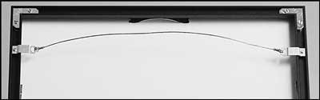

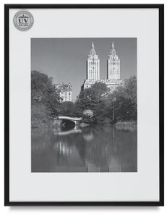
Avoid thin, weak plastic or metal frame that cannot support the hanging clips.
We are not responsible for damage to an improperly assembled frame.

Michaels, Hobby Lobby, and Joann’s all have coupons on a regular basis for ready-made frames or sectionals. With a sale/coupon,(search online) you can find a frame and glass for under $20.
IT IS NOT NECESSARY TO GET YOUR WORK PROFESSIONALLY FRAMED.

Selling Work
Students may price their work for sale. NO commission will be taken this year, however, if a piece is desired to be purchased on a date other than opening, buyers will have to go through either Alexandra Overby or Linda Slobodin via email or directly through the artist.

Awards
GRACe studios will award one merit prize for excellence and our judges will choose ribbons to exceptional works in the show. CPAC will be also awarding recognition to a few students. Additional awards will be communicated via our website.

Reception
Please join us for a reception in your honor on Friday, March 3rd, 6-9pm.
Refreshments will be served.

Please thank our sponsors for making our celebration possible– Denver Pro Photo, Colorado Photographic Arts Center (CPAC), and Mike’s Camera –by visiting them and supporting their businesses.

Questions?
Email Alexandra Overby at Alexandra_overby@dpsk12.org or look on the website http://denvermopteenshow.weebly.com

Contact Linda Slobodin at lslobodin@gmail.com

DIRECTIONS TO GRACe Studios: Globeville Riverfront Art Center

888 E 50th Ave

Denver, CO 80216

studiosatgrace@gmail.com

720-476-6710

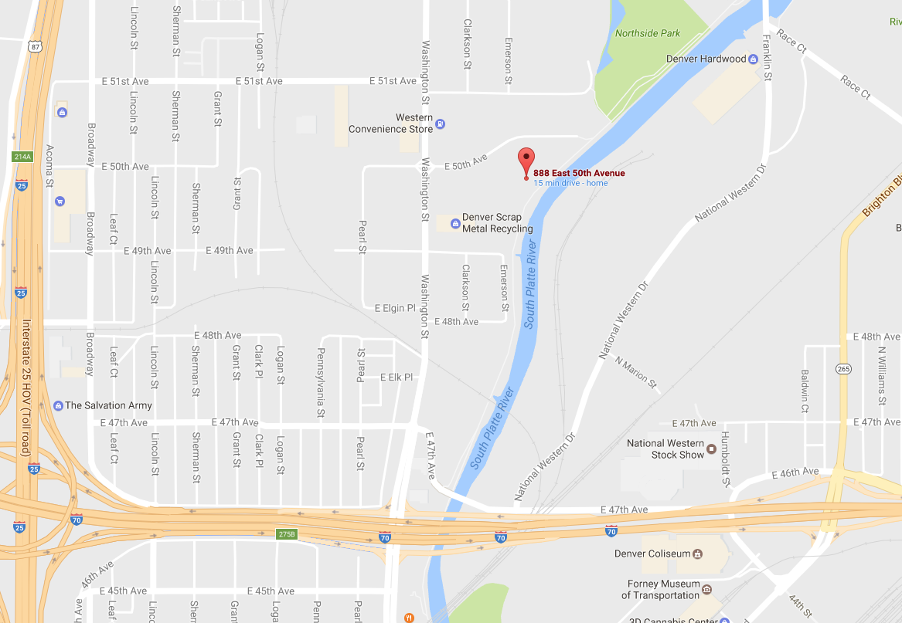

Please WRITE LEGIBLY and attach this form to the back of your work Name:________________________________________________________

Address: ________________________________________________________

City: ________________________________________ Zip _____________________

Email: _______________________________________________________________

Phone: _____________________________________________

Sale Price or Not For Sale (NFS) _______________________

School: ____________________________________________________

Photo Teacher: _____________________________________________

Teacher email:______________________________________________

Teacher phone: _____________________________________________

Title:______________________________________________________

